Regional Native Landscape Brochures
Chapter Suggested Edits (latest version dated 2017)

Suggestions Received as of 12/1/2024

Note:
- List will be reviewed to decide what changes to make for the 2025 printing cycle based on complexity (have limited manpower and time – print quote requests go out February 1)
- Some changes are not noted in all regions that they occur
- Suggested edits received from:
  - Al Squires (Central Region)
  - Cate Hurlbut (Northeast Region)
  - Marlene Rodak (West Coast Region)
  - Melanie Simon (Central Region)

GENERAL COMMENTS (All Brochures)
- It would be great to get the brochure online.

INFORMATION PAGES

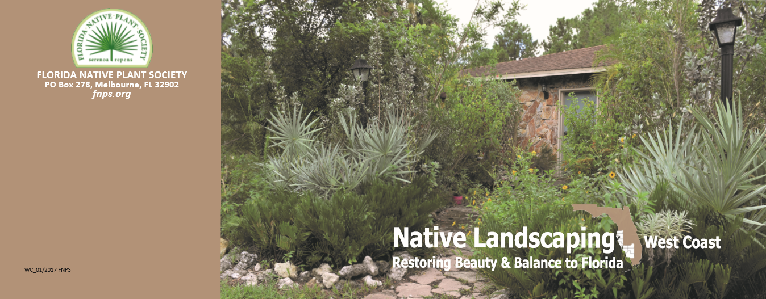

- Address change?
- If Chapters end up realigning, the map will need to be changed on for some regions.
- Add version and date – bottom right corner?

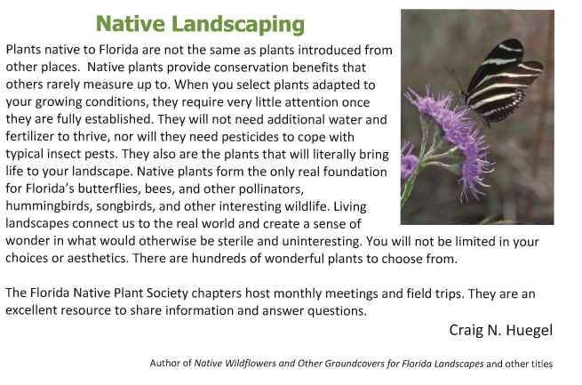

Native Landscaping
- “They will not need additional water and fertilizer to thrive” is totally false. There are times that supplemental watering will be necessary now as the summers get hotter & droughts are more often
- “Native plants form the only real foundation” ONLY is not true
- Native plants are not entirely pest free. For example, scale, lacebugs and fungus can damage native azaleas so it you don’t want to lose them some pest control products made from natural organic substances may be necessary.

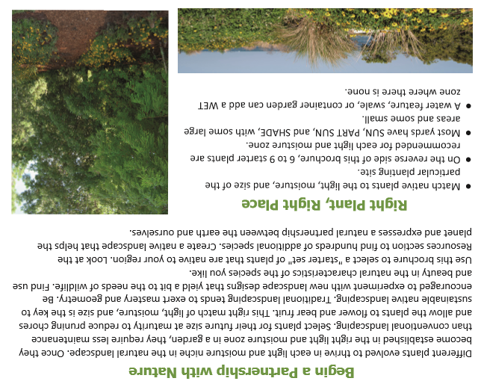

Right Plant, Right Place
- Add that plants selected should be suitable for the hardiness zone of your area
- Consider not only the moisture level of the soil but also the pH of the soil. Many of the county extension offices can test your soils pH level for free and pH testing kits are available in many of the garden centers
- Consider function and aesthetics; what do you want your plant to do and the planting area to look like

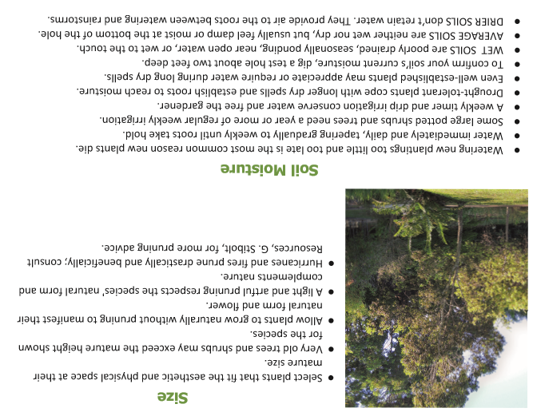

Soil Moisture
- Pay attention to weather forecast and rain chances before you apply any water or irrigation

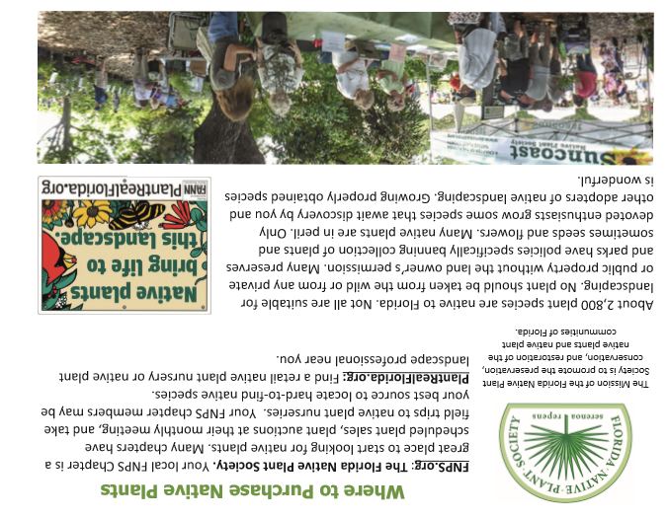

- Incorrect number of Florida native species given. The correct number is 3,317 (see https://florida.plantatlas.usf.edu) not 2,800. Change to “Over 3,000 . . . “

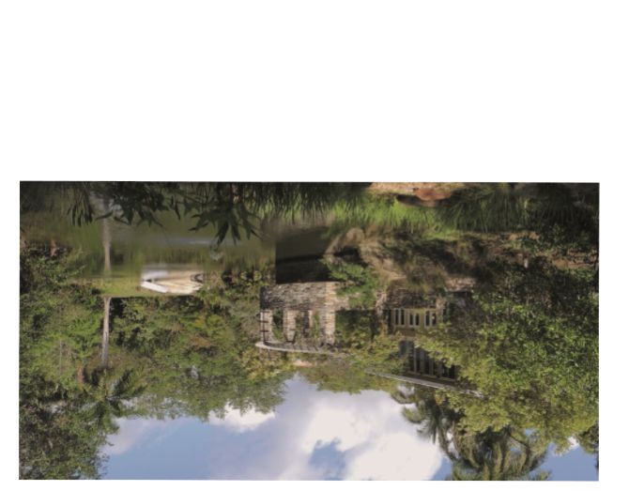

Replace the picture of a building over a lake on the brochure.
- Collage with labeled pictures of Landscape Award Winners?
- Northeast: Could we remove the image and instead provide information and perhaps a picture for Native Park? Native Park is a great local example of what a beautiful native garden looks like.

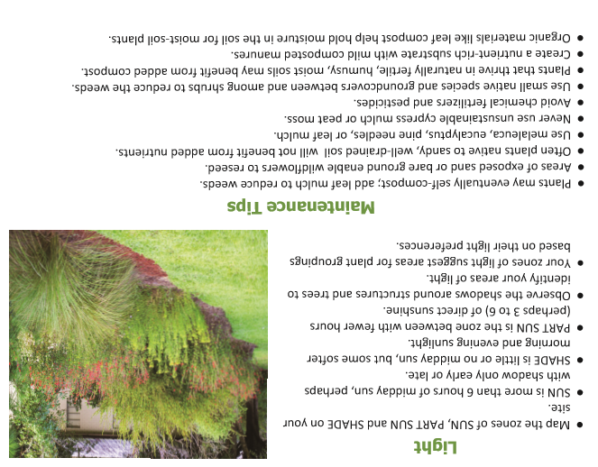

Light
- Consider where sun is during each part of the day as well as during the seasons; most plants can benefit by having some shade during mid afternoon in the summer when the sun and temperatures are the hottest

Maintenance Tips
- humusy is not a word that is familiar to many people. Is there room to put ‘full of humus’ instead?
- Caveat about using groundcovers among shrubs; need to wait until the shrubs are mature and roots well established at least a year or longer

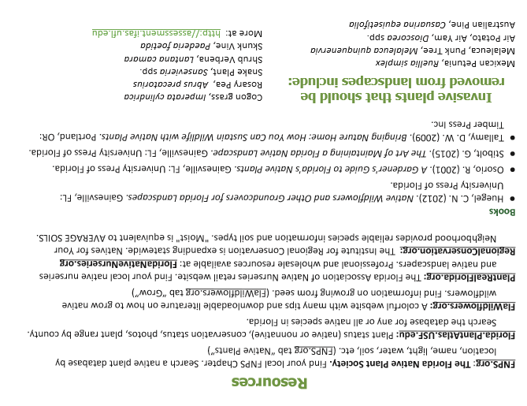

Note: Invasive plant list varies by region

- Snake Plant, Sansevieria spp" — this name changed to Dracaena hyacinthoides
- Shrub Verbena, Lantana camara – this name changed to Lantana strigocamara
- Northeast - In the list of Invasive Plants, orchid tree Bauhinia variegata is listed. This hasn’t been seen in the area or in garden centers. Perhaps replace it with Coral Ardisia Ardisia crenata which is a widespread invasive in this area.

- Check invasive plants listed in Good Citizen Guide insert

PLANT MATRIX

General Comments
- The grouping of plants into sun, part sun and shade is not accurate. Lots of the plants listed as Shade can take full sun. Perhaps they need to add a new grouping Sun to Shade. Or perhaps do away with the groupings and just list the Light requirements as part of the bullet points for each plant.
- It would be helpful if they indicated evergreen or deciduous for all of the plants

Plant Species
Change in all brochures in which they appear
- Sparkleberry is spelled wrong. (Sparkelberry)
- Remove blanketflower, Gaillardia pulchella, since it's no longer considered a native species.
- The species listed for the coontie, "pumila", is no longer recognized as the correct species for Florida. Z. pumila is endemic to the West Indies. The widely spread native coontie is Zamia integrifolia.
- Yaupon Holly – add ‘Females have fruit.” Dahoon Holly has comment “Females have fruit (need male)”.
- Why is there a variety given for Yellow Anise? Brochure has Illicium parviflorum ‘Forest Green’. FNPS and Florida.PlantAtlas has just scientific and common name, no variety. People from using the plant if they can’t find the variety. https://www.fnps.org/plant/illicium-parviflorum https://florida.plantatlas.usf.edu/plant.aspx?id=641
- Lopsided Indian Grass is described as salt tolerance. Change to salt tolerant to be consistent with other descriptions.
- Inconsistency in punctuation. Walter’s viburnum , Sparkleberry, Virginia willow are all described as Shrub/small tree while Simpson’s Stopper is Shrub, small tree.
- Inconsistent re profuse, showy flowers vs profuse showy flowers. Might just leave that be, the meaning comes across just fine.
- Add ‘reseeds’ to Carolina Petunia. (boy does it ever!).

PANHANDLE

NORTHEAST
Specific comments about growing these plants in NE FL area
Standing cypress, Ipomopsis rubra, would be a nice replacement in that category (dry, full sun).
Shade
- Coontie – full sun, part sun, shade
- Beautyberry – full sun, part shade
- Frostweed – part shade, shade; I have never seen this for sale anywhere in Jax area
- Carolina Wild Petunia – full sun, part sun, shade
- Simpson’s Stopper – full sun, part shade; prefers alkaline soil
- Pinxter Azalea – part shade; needs acidic soil
- Yellow Star Anise – shade
- Wild Coffee – part shade to shade; hard freeze will knock it back
- Rouge Plant – full sun, part shade, shade; evergreen; may bloom year round
- Fringe Tree – full sun, part shade; prefers acidic soil
- Flowering Dogwood – part shade; must have acidic soil as not tolerate any higher pH
- Virginia Willow – part shade, shade; prefers moist to wet soils
- Dahoon Holly – full sun, part shade, shade; need more moisture than other ilex species
- Cinnamon Fern – part shade to shade; prefers acidic soil; needs moist soil
- Shiny Lyonia – full sun to part shade; prefers acidic soil
- Swamp Azalea – part shade to shade; needs acidic soil & moist to wet locations
- Southern Arrowwood – full sun, part shade, shade

Sun
Generally, all the plants listed under Sun are full sun with a few being adaptable to part shade. All of the plants are tolerant of a range of soil pH.
- Replace Blanketflower with Standing cypress, Ipomopsis rubra, would be a nice replacement in that category (dry, full sun). NEED BULLET POINTS
- Frog Fruit – NOT highly salt-tolerant per FNPS own website
- Buttonbush – wetlands plant so probably not a good choice for most residential landscapes
- Scarlet Hibiscus – needs wet sites so probably not a good choice to include (REPLACEMENT???)
- Southern Blue Flag Iris – ditto about wet sites
- Yellow Canna – another one needing wet sites; why so many suddenly listed needing wet sites.
- Narrowleaf Sunflower – prefers acidic soil
- Rough Skullcap – this is very short lived and has never done well in Native Park; this is very short lived and often does not often reappear next season; people will plant this and then its gone and never come back will discourage people about native wildflowers
Part Sun
- Forked Bluecurls – full sun is ok
- Adams Needle – full sun is ok
- Shiny Blueberry – full sun is ok; short lived
- Rusty Lyonia – full sun; acidic soil prefer
- Tropical Sage – full sun is ok
- False Indigo – full sun is ok
- Eastern Redbud – full sun is ok
- Coral Bean – full sun to full shade
- Florida Greeneyes – full sun is ok
- Coral Honeysuckle – full sun is ok
- Florida Paintbrush – full sun is ok
- Sparkleberry – (correct spelling) prefers acidic soil
- Walter’s Viburnum – full sun is ok; prefers acidic soil
- Pipestem – prefers acidic soil
- Cardinal Flower – needs wet sites & acidic soil; most homeowners would never be successful with this plant
- String Lily – wetlands plant; would need constantly moist soil
- Pickerelweed – needs wet inundated sites; not sure why this is even listed

NORTH CENTRAL

CENTRAL

- Change Blanketflower Gaillardia pulchella to Pennyroyal Piloblephis rigida (drier, Sun section).
- Change Tropical sage Salvia coccinea to Yellowtop Flaveria linearis (drier, Sun section). (Disagree about removing Salvia).
- Replace???? with Blue Porterweed Stachytarpheta jamaicensis (have Marjorie Shropshire photo)
  - Short lived perennial flower
  - .5 – 1 ft tall, 3-4 ft. wide (or spreads?)
  - Showy flowers
  - Attracts pollinators and hummingbirds
- Coontie – Change name to Zamia integrifolia
- Replace Yellow Buttons – hard to find
- Replace Scrub Hickory – hard to find

WEST COAST

Note: Changes already made
- Snake Plant, Sansevieria spp" — this name changed to Dracaena hyacinthoides
- Sulzner’s Coffee – Change name to Shortleaf Wild Coffee Psychotria tenuifolia
- Myrsine – Change name to Myrsine cubana
- Swamp Fern – Change name to Telmatoblechnum serrulatum
- Replace Blanketflower with Blue Porterweed Stachytarpheta jamaicensis (have Marjorie Shropshire photo)
  - Short lived perennial flower
  - .5 – 1 ft tall, 3-4 ft. wide
  - Showy flowers
  - Attracts pollinators and hummingbirds Replace Blanketflower with Blue Porterweed
- Gopher Apple – Change name to Geobalanus oblongifolius
- Coontie – Change name to Zamia integrifolia

SOUTHEAST

